Pointer to structure / pointer structure variables: 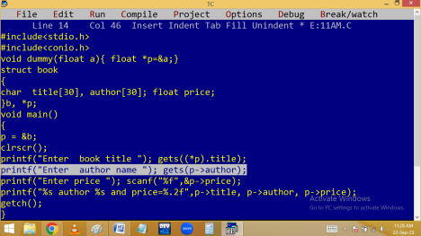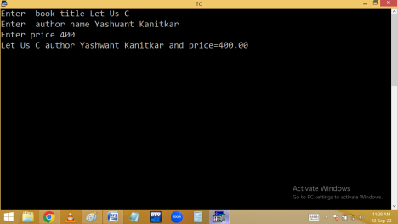Array of structure:
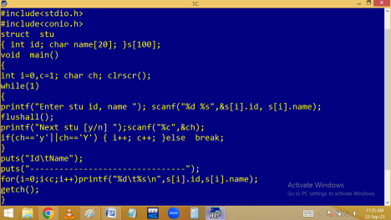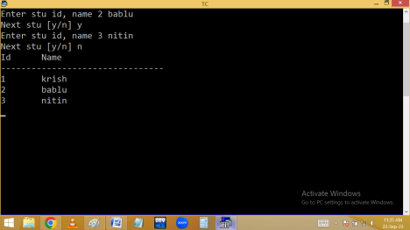Dynamic structures:
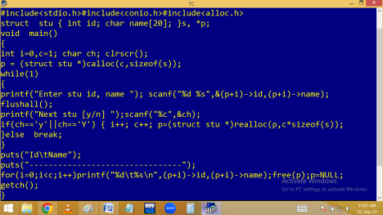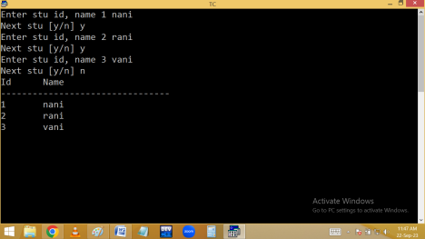
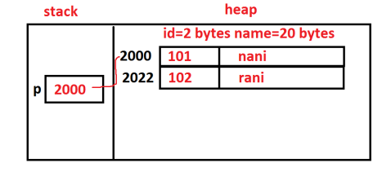Passing structure to function:
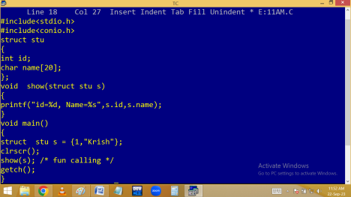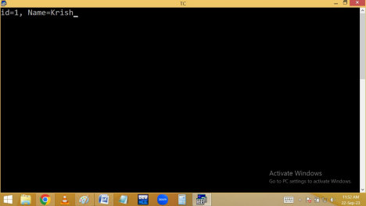Function returning structure:
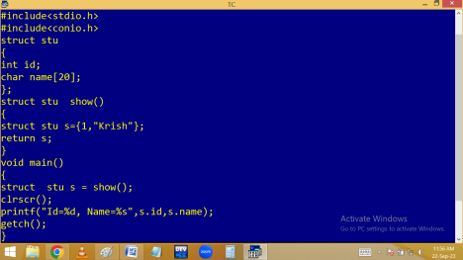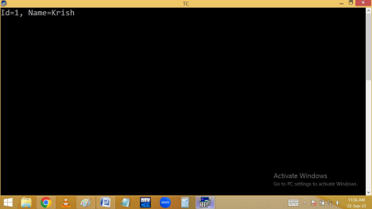
Nested structure / Embedded structure:
Declaring a structure / structure variable within another structure. It allows the concept of reusability.
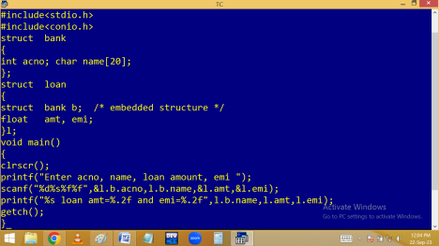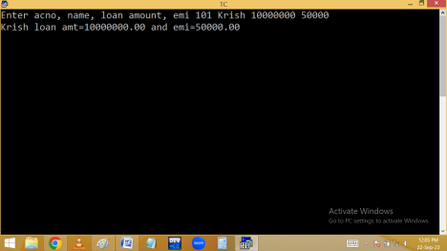
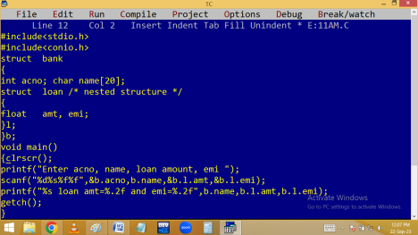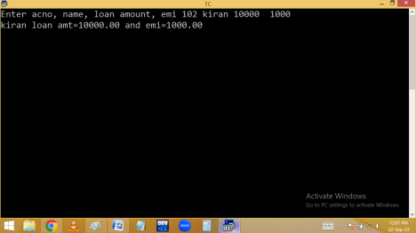
UNION
It is a user defined data type.
union is a keyword.
Like the structures unions are also used to place several variables of different data types under one name. But the main difference is all union members are having common memory/ one memory.
In structure memory allocated for all the structure members separately. But in union one memory allocated and it is used by all the union members. We can access all the structure members at a time. But in union one member is active at a time. Structure size is sum of all the structure members. Union size is biggest union member size.
There is a situation where we have several options and user has to select one then go for union.
Syntax:
union [ <union-tag-name> ]
{
datatype variable1;
datatype variable2;
} union variables;
🡺Declaration and Accessing of union members is similar to the structures.
Eg: Finding union size:
#include<stdio.h>
#include<conio.h>
union stu
{
int id;
char name[20];
float fee;
}s;
void main()
{
printf(“Union size %d bytes”, sizeof(s));
getch();
}
Output: Union size 20 bytes.
Eg:
Direct Initialization of union members:
Note: In union only the first member is initialized directly.
#include<stdio.h>
#include<conio.h>
union stu
{
int id;
char name[20];
float fee;
}s={1001,"krish",10000};
void main()
{
clrscr();
printf("Id=%d\nName=%s\nFee=%.2f",s.id, s.name, s.fee);
getch();
}
Output: Initializer syntax error
Solution: s = {1001} ;
Eg:
Accessing union members:
#include<stdio.h>
#include<conio.h>
union sample
{
int a;
long int b;
};
void main()
{
union sample s;
clrscr();
s.a=100;
printf("a = %d\n", s.a);
s.b=200;
printf("b = %ld", s.b);
getch();
}
Output
a = 100
b = 200
Differences between structure and union:
STRUCTURE | UNION
All the structure | Only one union member

members are active at a time. | is active at a time.
memory is allocated for all the structure  members | memory allocated for the variable, which requires more memory in the union.
All the structure  members initialized at a time. | Only the first member of union is initialized.
Structure size is sum of all the structure  members. | Union size is the biggest variable data type size in the entire union.
They are useful to  declare a compound data type to group data  members related to person or item etc. | It is useful in certain situation where the user will select any one data member from group of data members.

